To push a file in global repo

DELL@DESKTOP-4H5ELHE MINGW64 ~

**$ mkdir test**

DELL@DESKTOP-4H5ELHE MINGW64 ~

**$ cd test**

DELL@DESKTOP-4H5ELHE MINGW64 ~/test

**$ git init**

Initialized empty Git repository in C:/Users/DELL/test/.git/

DELL@DESKTOP-4H5ELHE MINGW64 ~/test (master)

**$ git status**

On branch master

No commits yet

Untracked files:

(use "git add <file>..." to include in what will be committed)

demo.txt

nothing added to commit but untracked files present (use "git add" to track)

DELL@DESKTOP-4H5ELHE MINGW64 ~/test (master)

**$ git add demo.txt**

DELL@DESKTOP-4H5ELHE MINGW64 ~/test (master)

**$ git commit -m "Commiting a txt folder"**

[master (root-commit) 4b212d7] Commiting a txt folder

1 file changed, 1 insertion(+)

create mode 100644 demo.txt

DELL@DESKTOP-4H5ELHE MINGW64 ~/test (master)

**$ git config --global user.username "SekharShrestha"**

DELL@DESKTOP-4H5ELHE MINGW64 ~/test (master)

**$ git remote add origin https://github.com/SekharShrestha/test_demo.git**

DELL@DESKTOP-4H5ELHE MINGW64 ~/test (master)

**$ git push origin master**

Enumerating objects: 3, done.

Counting objects: 100% (3/3), done.

Writing objects: 100% (3/3), 228 bytes | 228.00 KiB/s, done.

Total 3 (delta 0), reused 0 (delta 0), pack-reused 0

To https://github.com/SekharShrestha/test_demo.git

* [new branch] master -> master

**From SSH repo**

DELL@DESKTOP-4H5ELHE MINGW64 /C/Users/Dell/myProjectDir (master)

**$ ssh-keygen**

Generating public/private rsa key pair.

Enter file in which to save the key (/c/Users/DELL/.ssh/id_rsa):

Created directory '/c/Users/DELL/.ssh'.

Enter passphrase (empty for no passphrase):

Enter same passphrase again:

Your identification has been saved in /c/Users/DELL/.ssh/id_rsa

Your public key has been saved in /c/Users/DELL/.ssh/id_rsa.pub

The key fingerprint is:

SHA256:ZlTJu0MX7cFX+5nSjSMbJtFI608yFxr9bBvJB2NLq4M DELL@DESKTOP-4H5ELHE

The key's randomart image is:

+---[RSA 3072]----+

| .o. o o|

| oo=. + o|

| . =.+o=+ |

| . .o+.BoB=|

| S.*o*.%++|

| o oX *.= |

| E.= . |

| . |

| |

+----[SHA256]-----+

DELL@DESKTOP-4H5ELHE MINGW64 /C/Users/Dell/myProjectDir (master)

**$ cat /c/Users/DELL/.ssh/id_rsa.pub //add .pub after location**

ssh-rsa  DELL@DESKTOP-4H5ELHE

***Goto GitHub -> setting -> SSH and GPG keys*** [***https://github.com/settings/keys***](https://github.com/settings/keys)

***Add the key in new ssh key***

DELL@DESKTOP-4H5ELHE MINGW64 /C/Users/Dell/myProjectDir (master)

**$ git remote add origin git@github.com:SekharShrestha/mySSHkey.git**

error: remote origin already exists.

DELL@DESKTOP-4H5ELHE MINGW64 /C/Users/Dell/myProjectDir (master)

**$ git remote remove origin //to remove prev remote origin**

DELL@DESKTOP-4H5ELHE MINGW64 /C/Users/Dell/myProjectDir (master)

**$ git remote add origin git@github.com:SekharShrestha/mySSHkey.git**

DELL@DESKTOP-4H5ELHE MINGW64 /C/Users/Dell/myProjectDir (master)

**$ git push origin master**

The authenticity of host 'github.com (13.234.210.38)' can't be established.

ED25519 key fingerprint is SHA256:+DiY3wvvV6TuJJhbpZisF/zLDA0zPMSvHdkr4UvCOqU.

This key is not known by any other names

Are you sure you want to continue connecting (yes/no/[fingerprint])? yes

Warning: Permanently added 'github.com' (ED25519) to the list of known hosts.

Enumerating objects: 15, done.

Counting objects: 100% (15/15), done.

Delta compression using up to 8 threads

Compressing objects: 100% (7/7), done.

Writing objects: 100% (15/15), 1.15 KiB | 196.00 KiB/s, done.

Total 15 (delta 0), reused 0 (delta 0), pack-reused 0

To github.com:SekharShrestha/mySSHkey.git

* [new branch] master -> master

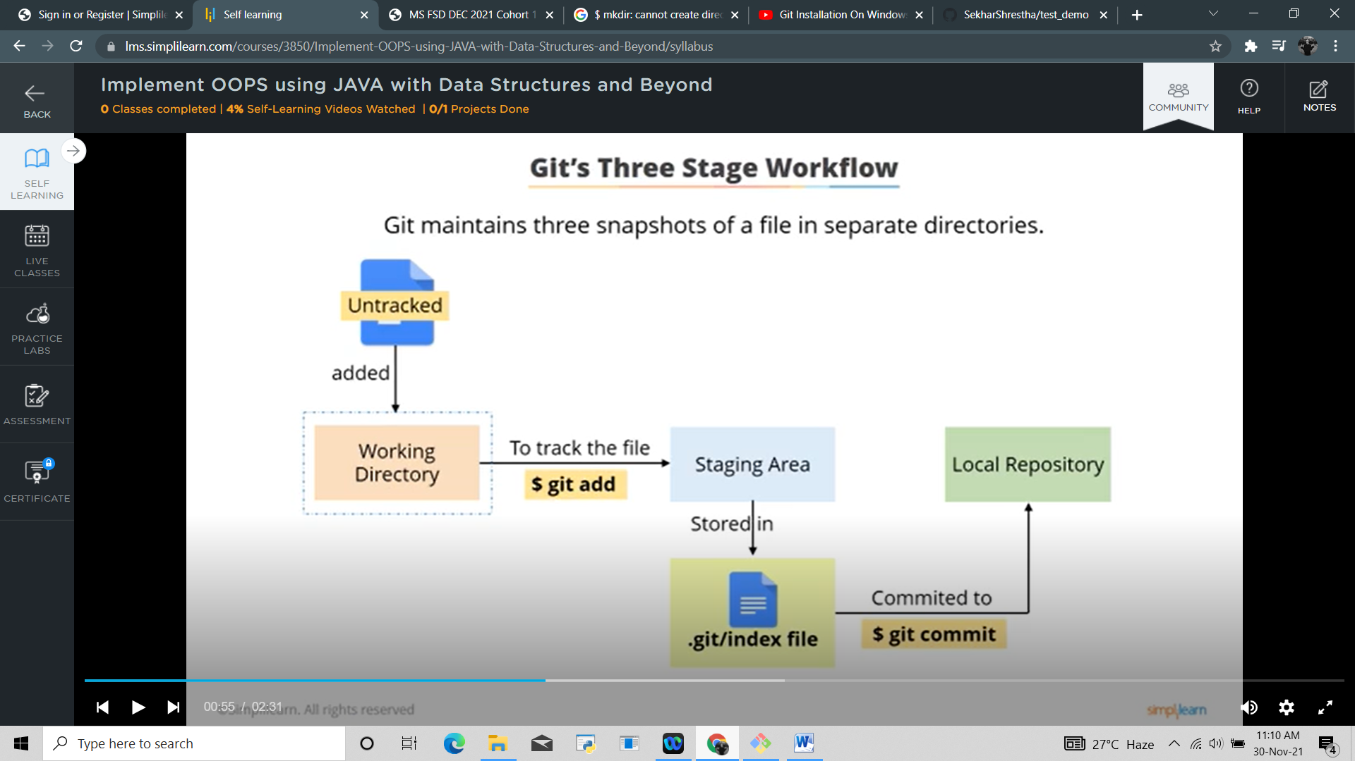

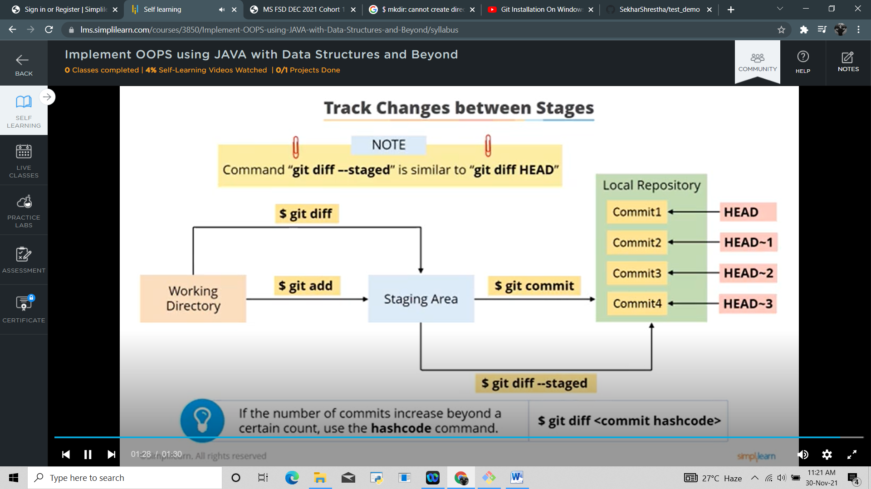

DELL@DESKTOP-4H5ELHE MINGW64 ~/myProjectDir (master)

**$ touch index.txt //created index.txt in mkdir**

DELL@DESKTOP-4H5ELHE MINGW64 ~/myProjectDir (master)

**$ git status**

On branch master

No commits yet

Untracked files:

(use "git add <file>..." to include in what will be committed)

index.txt

nothing added to commit but untracked files present (use "git add" to track)

DELL@DESKTOP-4H5ELHE MINGW64 ~/myProjectDir (master)

**$ git add index.txt //added index in staging area**

DELL@DESKTOP-4H5ELHE MINGW64 ~/myProjectDir (master)

**$ git status // status check**

On branch master

No commits yet

Changes to be committed:

(use "git rm --cached <file>..." to unstage)

new file: index.txt

DELL@DESKTOP-4H5ELHE MINGW64 ~/myProjectDir (master)

**$ git commit -m "Commit" //commit to local repo**

[master (root-commit) 499d6fe] Commit

1 file changed, 0 insertions(+), 0 deletions(-)

create mode 100644 index.txt

DELL@DESKTOP-4H5ELHE MINGW64 ~/myProjectDir (master)

**$ git status**

On branch master

nothing to commit, working tree clean

DELL@DESKTOP-4H5ELHE MINGW64 ~/myProjectDir (master)

**$ git log //displays all of the commits in a repository's history**

commit 499d6fef03b95a5c16c2b53e58a13e1e5d853d32 (HEAD -> master)

Author: Sekhar Shrestha <seshrestha17@gmail.com>

Date: Tue Nov 30 11:15:24 2021 +0530

Commit

DELL@DESKTOP-4H5ELHE MINGW64 ~/myProjectDir (master)

**$ git diff index.txt**

//Now I change the content of the .txt file

DELL@DESKTOP-4H5ELHE MINGW64 ~/myProjectDir (master)

**$ git status // status check**

On branch master

Changes not staged for commit:

(use "git add <file>..." to update what will be committed)

(use "git restore <file>..." to discard changes in working directory)

modified: index.txt

no changes added to commit (use "git add" and/or "git commit -a")

DELL@DESKTOP-4H5ELHE MINGW64 ~/myProjectDir (master)

$ git diff index.txt //show the different changes done to the file

**diff --git a/index.txt b/index.txt**

**index e69de29..eb69762 100644**

**--- a/index.txt**

**+++ b/index.txt**

@@ -0,0 +1 @@

+helicopter

\ No newline at end of file

DELL@DESKTOP-4H5ELHE MINGW64 ~/myProjectDir (master)

**$ git add index.txt //added index in staging area**

DELL@DESKTOP-4H5ELHE MINGW64 ~/myProjectDir (master)

$ git diff --staged

**diff --git a/index.txt b/index.txt**

**index e69de29..eb69762 100644**

**--- a/index.txt**

**+++ b/index.txt**

@@ -0,0 +1 @@

+helicopter

\ No newline at end of file

DELL@DESKTOP-4H5ELHE MINGW64 ~/myProjectDir (master)

**$ git log**

commit 499d6fef03b95a5c16c2b53e58a13e1e5d853d32 (HEAD -> master)

Author: Sekhar Shrestha <seshrestha17@gmail.com>

Date: Tue Nov 30 11:15:24 2021 +0530

Commit

DELL@DESKTOP-4H5ELHE MINGW64 ~/myProjectDir (master)

**$ git diff --staged Head //show the 1st change done to the file from staging to repo**

**diff --git a/index.txt b/index.txt**

**index e69de29..eb69762 100644**

**--- a/index.txt**

**+++ b/index.txt**

@@ -0,0 +1 @@

+helicopter

\ No newline at end of file

DELL@DESKTOP-4H5ELHE MINGW64 ~/myProjectDir (master)

**$ git diff --staged Head~1 //show the 2nd change done to the file from staging to repo**

fatal: ambiguous argument 'Head~1': unknown revision or path not in the working tree.

Use '--' to separate paths from revisions, like this:

'git <command> [<revision>...] -- [<file>...]'

DELL@DESKTOP-4H5ELHE MINGW64 ~/myProjectDir (master)

$ git log

commit 499d6fef03b95a5c16c2b53e58a13e1e5d853d32 (HEAD -> master)

Author: Sekhar Shrestha <seshrestha17@gmail.com>

Date: Tue Nov 30 11:15:24 2021 +0530

Commit

DELL@DESKTOP-4H5ELHE MINGW64 ~/myProjectDir (master)

$ git status

On branch master

Changes to be committed:

(use "git restore --staged <file>..." to unstage)

modified: index.txt

DELL@DESKTOP-4H5ELHE MINGW64 ~/myProjectDir (master)

**$ git commit -m "commit" //commit to repo**

[master ecb40d3] commit

1 file changed, 1 insertion(+)

DELL@DESKTOP-4H5ELHE MINGW64 ~/myProjectDir (master)

$ git log

commit ecb40d3f4c21c464f2428f0ce151baca1077ac1f (HEAD -> master)

Author: Sekhar Shrestha <seshrestha17@gmail.com>

Date: Tue Nov 30 11:37:31 2021 +0530

commit

commit 499d6fef03b95a5c16c2b53e58a13e1e5d853d32

Author: Sekhar Shrestha <seshrestha17@gmail.com>

Date: Tue Nov 30 11:15:24 2021 +0530

Commit

DELL@DESKTOP-4H5ELHE MINGW64 ~/myProjectDir (master)

**$ git ls-files –-stage //list of files staged**

100644 fbeb6242896ecd4b4a362258d54a384e2cdc3fbb 0 index.txt

DELL@DESKTOP-4H5ELHE MINGW64 ~/myProjectDir (master)

**$ git ls-files --stage //list of files staged**

100644 2b31011cf9de6c82d52dc386cd7d1a9be83188c1 0 a.txt.txt

100644 deb1e302ad73ed9e1d06b13d5e56a96ce6cca74e 0 asfdg.txt

100644 fbeb6242896ecd4b4a362258d54a384e2cdc3fbb 0 index.txt

DELL@DESKTOP-4H5ELHE MINGW64 ~/myProjectDir (master)

**$ git rm --cached a.txt.txt //remove a.txt.txt from stage**

rm 'a.txt.txt'

DELL@DESKTOP-4H5ELHE MINGW64 ~/myProjectDir (master)

$ git ls-files --stage //list of files staged

100644 deb1e302ad73ed9e1d06b13d5e56a96ce6cca74e 0 asfdg.txt

100644 fbeb6242896ecd4b4a362258d54a384e2cdc3fbb 0 index.txt

**Pull commit from GitHub**

DELL@DESKTOP-4H5ELHE MINGW64 /C/Users/Dell/myProjectDir (master)

$ git log –-oneline

72af881 (HEAD -> master, origin/master) a.txt.txt

0a8bb86 commit new

dc93e31 commiter

ecb40d3 commit

499d6fe Commit

DELL@DESKTOP-4H5ELHE MINGW64 /C/Users/Dell/myProjectDir (master)

**$ git pull origin master //to pull the commits done in github**

remote: Enumerating objects: 5, done.

remote: Counting objects: 100% (5/5), done.

remote: Compressing objects: 100% (2/2), done.

remote: Total 3 (delta 1), reused 0 (delta 0), pack-reused 0

Unpacking objects: 100% (3/3), 650 bytes | 3.00 KiB/s, done.

From github.com:SekharShrestha/mySSHkey

* branch master -> FETCH_HEAD

72af881..4b170f0 master -> origin/master

Updating 72af881..4b170f0

Fast-forward

index.txt | 2 +-

1 file changed, 1 insertion(+), 1 deletion(-)

DELL@DESKTOP-4H5ELHE MINGW64 /C/Users/Dell/myProjectDir (master)

**$ git log --oneline**

4b170f0 (HEAD -> master, origin/master) chg //github commit shown now

72af881 a.txt.txt

0a8bb86 commit new

dc93e31 commiter

ecb40d3 commit

499d6fe Commit

**Branching**

DELL@DESKTOP-4H5ELHE MINGW64 /C/Users/Dell/myProjectDir (master)

**$ git branch //shows no. of branches present**

* master

DELL@DESKTOP-4H5ELHE MINGW64 /C/Users/Dell/myProjectDir (master)

**$ git branch feature //create new branch named feature**

DELL@DESKTOP-4H5ELHE MINGW64 /C/Users/Dell/myProjectDir (master)

$ git branch

feature

* master

DELL@DESKTOP-4H5ELHE MINGW64 /C/Users/Dell/myProjectDir (master)

**$ git checkout feature //switch to branch feature**

Switched to branch 'feature'

DELL@DESKTOP-4H5ELHE MINGW64 /C/Users/Dell/myProjectDir (feature)

$ git branch

* feature

master

DELL@DESKTOP-4H5ELHE MINGW64 /C/Users/Dell/myProjectDir (feature)

**$ git log –-oneline //shows same commits as of master branch**

63a0d07 (HEAD -> feature, origin/master, master) hirified

7a7b22b huriya

7c2d25a huriddi

39c9567 lo lo

4b170f0 chg

72af881 a.txt.txt

0a8bb86 commit new

dc93e31 commiter

ecb40d3 commit

499d6fe Commit

DELL@DESKTOP-4H5ELHE MINGW64 /C/Users/Dell/myProjectDir (feature)

**$ git add asfdg.txt**

DELL@DESKTOP-4H5ELHE MINGW64 /C/Users/Dell/myProjectDir (feature)

$ git commit -m "asfdg"

[feature 05015cc] asfdg

1 file changed, 1 insertion(+), 1 deletion(-)

DELL@DESKTOP-4H5ELHE MINGW64 /C/Users/Dell/myProjectDir (feature)

**$ git log --oneline**

05015cc (HEAD -> feature) asfdg

63a0d07 (origin/master, master) hirified

7a7b22b huriya

7c2d25a huriddi

39c9567 lo lo

4b170f0 chg

72af881 a.txt.txt

0a8bb86 commit new

dc93e31 commiter

ecb40d3 commit

499d6fe Commit

DELL@DESKTOP-4H5ELHE MINGW64 /C/Users/Dell/myProjectDir (feature)

**$ git checkout master**

Switched to branch 'master'

DELL@DESKTOP-4H5ELHE MINGW64 /C/Users/Dell/myProjectDir (master)

**$ git log –oneline //commits in feature won’t be showing in master**

63a0d07 (HEAD -> master, origin/master) hirified

7a7b22b huriya

7c2d25a huriddi

39c9567 lo lo

4b170f0 chg

72af881 a.txt.txt

0a8bb86 commit new

dc93e31 commiter

ecb40d3 commit

DELL@DESKTOP-4H5ELHE MINGW64 /C/Users/Dell/myProjectDir (master)

**$ git diff master..feature //show diff bw master and feature**

**diff --git a/asfdg.txt b/asfdg.txt**

**index deb1e30..1aecf46 100644**

**--- a/asfdg.txt**

**+++ b/asfdg.txt**

@@ -1 +1 @@

-hitler

\ No newline at end of file

+hellohitler

\ No newline at end of file

DELL@DESKTOP-4H5ELHE MINGW64 /C/Users/Dell/myProjectDir (master)

**$ git merge feature //merge feature content into branch**

Updating 63a0d07..05015cc

Fast-forward

asfdg.txt | 2 +-

1 file changed, 1 insertion(+), 1 deletion(-)

DELL@DESKTOP-4H5ELHE MINGW64 /C/Users/Dell/myProjectDir (master)

**$ git branch**

feature

feature1

* master

DELL@DESKTOP-4H5ELHE MINGW64 /C/Users/Dell/myProjectDir (master)

**$ git diff master..feature //no result, as both’s contents now same**

DELL@DESKTOP-4H5ELHE MINGW64 /C/Users/Dell/myProjectDir (master)

**$ git log --oneline**

05015cc (HEAD -> master, feature) asfdg //commits common in feature and master

63a0d07 (origin/master, feature1) hirified //commits common in feature1 and master

7a7b22b huriya

7c2d25a huriddi

39c9567 lo lo

4b170f0 chg

72af881 a.txt.txt

0a8bb86 commit new

dc93e31 commiter

ecb40d3 commit

499d6fe Commit

In case of conflict due to multiple chg in multiple branches

DELL@DESKTOP-4H5ELHE MINGW64 /C/Users/Dell/myProjectDir (master)

**$ git checkout feature1**

Switched to branch 'feature1'

DELL@DESKTOP-4H5ELHE MINGW64 /C/Users/Dell/myProjectDir (feature1)

**$ git status**

On branch feature1

Changes not staged for commit:

(use "git add <file>..." to update what will be committed)

(use "git restore <file>..." to discard changes in working directory)

modified: asfdg.txt

no changes added to commit (use "git add" and/or "git commit -a")

DELL@DESKTOP-4H5ELHE MINGW64 /C/Users/Dell/myProjectDir (feature1)

**$ git diff**

**diff --git a/asfdg.txt b/asfdg.txt**

**index deb1e30..3cc6f70 100644**

**--- a/asfdg.txt**

**+++ b/asfdg.txt**

@@ -1 +1 @@

-hitler

\ No newline at end of file

+holahitler

\ No newline at end of file

DELL@DESKTOP-4H5ELHE MINGW64 /C/Users/Dell/myProjectDir (feature1)

**$ git add asfdg.txt**

DELL@DESKTOP-4H5ELHE MINGW64 /C/Users/Dell/myProjectDir (feature1)

**$ git commit -m "asfdg feature1"**

[feature1 430c033] asfdg feature1

1 file changed, 1 insertion(+), 1 deletion(-)

DELL@DESKTOP-4H5ELHE MINGW64 /C/Users/Dell/myProjectDir (feature1)

**$ git status**

On branch feature1

nothing to commit, working tree clean

DELL@DESKTOP-4H5ELHE MINGW64 /C/Users/Dell/myProjectDir (feature1)

**$ git checkout master**

Switched to branch 'master'

DELL@DESKTOP-4H5ELHE MINGW64 /C/Users/Dell/myProjectDir (master)

**$ git diff master..feature1**

**diff --git a/asfdg.txt b/asfdg.txt**

**index 1aecf46..3cc6f70 100644**

**--- a/asfdg.txt**

**+++ b/asfdg.txt**

@@ -1 +1 @@

-hellohitler

\ No newline at end of file

+holahitler

\ No newline at end of file

DELL@DESKTOP-4H5ELHE MINGW64 /C/Users/Dell/myProjectDir (master)

**$ git merge feature1**

Auto-merging asfdg.txt

CONFLICT (content): Merge conflict in asfdg.txt

Automatic merge failed; fix conflicts and then commit the result.

DELL@DESKTOP-4H5ELHE MINGW64 /C/Users/Dell/myProjectDir (master|MERGING)

**$ git status**

On branch master

You have unmerged paths.

(fix conflicts and run "git commit")

(use "git merge --abort" to abort the merge)

Unmerged paths:

(use "git add <file>..." to mark resolution)

both modified: asfdg.txt

no changes added to commit (use "git add" and/or "git commit -a")

DELL@DESKTOP-4H5ELHE MINGW64 /C/Users/Dell/myProjectDir (master|MERGING)

**$ git diff**

**diff --cc asfdg.txt**

**index 1aecf46,3cc6f70..0000000**

**--- a/asfdg.txt**

**+++ b/asfdg.txt**

@@@ -1,1 -1,1 +1,1 @@@

- hellohitler

-holahitler

++hellohitler

DELL@DESKTOP-4H5ELHE MINGW64 /C/Users/Dell/myProjectDir (master|MERGING)

**$ git add asfdg.txt**

DELL@DESKTOP-4H5ELHE MINGW64 /C/Users/Dell/myProjectDir (master|MERGING)

**$ git commit -m "feature1 chg"**

[master 44590df] feature1 chg

DELL@DESKTOP-4H5ELHE MINGW64 /C/Users/Dell/myProjectDir (master)

**$ git log --oneline**

44590df (HEAD -> master) feature1 chg

430c033 (feature1) asfdg feature1

05015cc (feature) asfdg

63a0d07 (origin/master) hirified

7a7b22b huriya

7c2d25a huriddi

39c9567 lo lo

4b170f0 chg

72af881 a.txt.txt

0a8bb86 commit new

dc93e31 commiter

ecb40d3 commit

499d6fe Commit